# Lesson 11 Test the IR remote controller

**Table**

[1. What do you need to prepare 1](#_Toc143616760)

[2. Principle 2](#_Toc143616761)

[3. Wiring 4](#_Toc143616762)

[4. Upload the code and test 5](#_Toc143616763)

[5. Code 8](#_Toc143616764)

[6. Any questions and suggestions are welcome 9](#_Toc143616765)

# 1. What do you need to prepare

|  |  |  |
| --- | --- | --- |
| Components | Quantity | Picture |
| USB cable | 1 |  |
| Infrared remote controller | 1 | D:\360Downloads\Software\WeChat Files\WeChat Files\wxid_isa7z2vq3d8l22\FileStorage\Temp\1660805641514.png |
| Control board | 1 |  |

# 2. Principle

Infrared remote control by transmitting and receiving two components. The transmitter uses microcontroller to encode and modulate the binary signal to be sent into a series of pulse train signals, which are transmitted through the infrared transmitter tube. Infrared reception completes the reception, amplification, detection, shaping of infrared signals, and demodulation of remote coding pulse. In order to reduce interference, an integrated infrared receiver (HS0038, which receives infrared signals with a frequency of 38kHz and a period of about 26μs, and adopts NEC infrared coding) is used to receive infrared signals. At the same time, HS0038 amplifies, detects and shapes the signals to obtain the coded signals of TTL level, which is then sent to the microcontroller. The MCU decoded and executed to control the related objects.

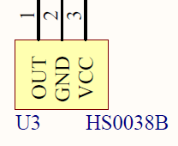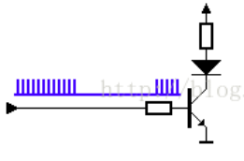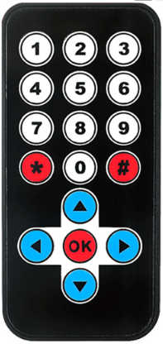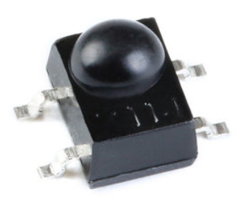

Infrared remote control transmitter

Infrared remote control receiver

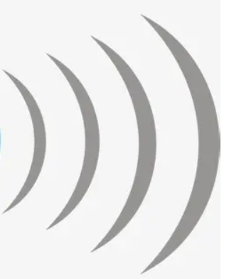

HS0038 infrared receiver, which internal integration of monitoring, amplification, filtering, demodulation and a series of circuits to process the output baseband signal. The original signal is a data "0" bit or a data "1" bit that we want to send, while the so-called 38K carrier is a square wave signal with a frequency of 38K, and the modulated signal is the final waveform that we transmit. We use the original signal to control the 38K carrier. When the signal is data "0", all the 38K carrier is sent without reservation. When the signal is data "1", no carrier signal is sent.

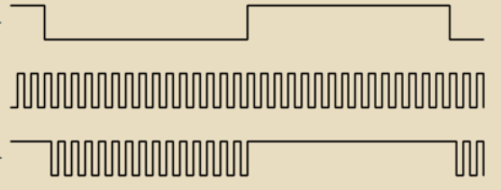

The original signal

32K Carrier

The modulated signal

The schematic diagram:

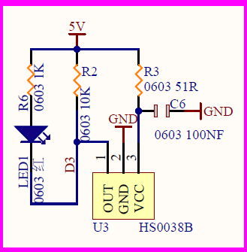

The infrared remote control receiver HS0038B mounted on the control board, and it occupies the D3 pin of the Atmega328p.HS0038B receives the signal from the controller,then modulated it and transmitts to Atmega328p MCU by D3.

# 3. Wiring

Connect the control board to the computer via a USB cable, Get an infrared remote control and place it next to the control board.

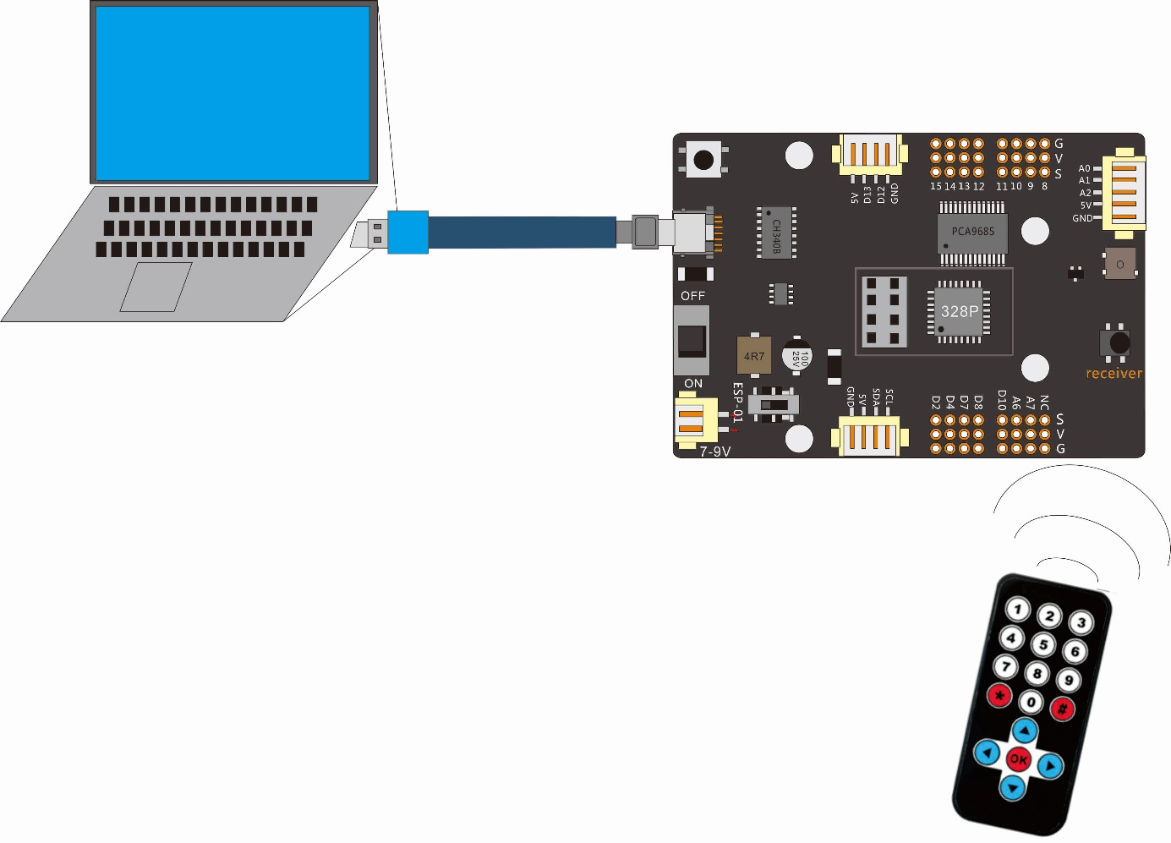

# 4. Upload the code and test

The code used in this lesson is placed in this folder：“ E:\CKK0002-master\Tutorial\sketches”

4.1 Double-click the Arduino IDE shortcut on the desktop to open it

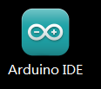

4.2 Click "File" --- "open"

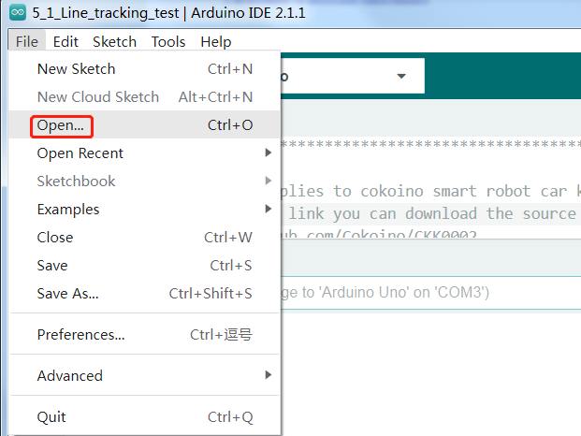

4.3 Select the code in the folder named 9\_1\_IR\_test：

E:\CKK0002-master\Tutorial\sketches\9\_1\_IR\_test，Click "open"

4.4 Select the board "Arduino UNO"and Port "COM3" (COM port is commonly known as an input output port for a device normally PC which enables communication between Arduino and PC. You can check your arduino com number in device manager, the com port of our arduino board is recognized as COM3 in this tutorial)

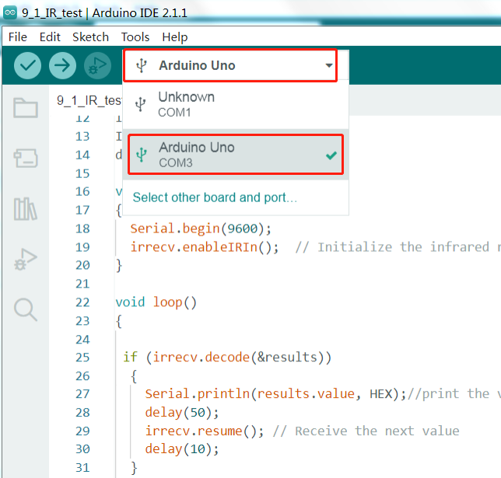

4.5 Install IRremote library

For the installation method, please refer to the method of installing the library Servo.h in Lesson 4

Note that to run the sample code of this lesson, you need to install the Irremote library version below 4.0.0, and the library version 4.0.0 and above does not support this sample code. In this lesson, we installed the “3.9.0 Irremote”

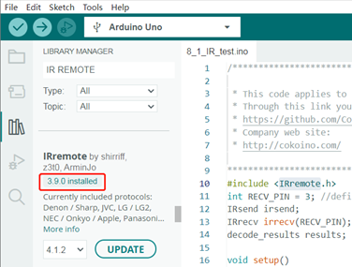

4.6 Click compile button，successfully compiled the code will display “Done compiling”

4.7 Before uploading the code, turn the ESP-01 switch on the control board to the side away from the "ESP-01" silk screen.

4.8 Click upload button，successfully uploading the code will display “Done uploading”. When code is uploaded successfully, the program starts to run.

4.9 After the code is successfully uploaded, open the Serial Monitor, select the baud rate as 9600, then pick up the infrared remote control and press the remote control button against the control board.You can see the value of the button on the remote control in the Serial Monitor window, which is the button signal received by the infrared receiver and printed out in HEX format. Pressing different buttons will print out different values in the Serial Monitor window.

|  |  |  |  |
| --- | --- | --- | --- |
| Number Labels of Infrared Remote Buttons | The value received by the infrared receiver | Number Labels of Infrared Remote | The value received by the infrared receiver |
| 0 | FF9867 | 9 | FF906F |
| 1 | FFA25D | \* | FF6897 |
| 2 | FF629D | # | FFB04F |
| 3 | FFE21D | ↑ | FF18E7 |
| 4 | FF22DD | ← | FF10EF |
| 5 | FF02FD | → | FF5AA5 |
| 6 | FFC23D | ↓ | FF4AB5 |
| 7 | FFE01F | Ok | FF38C7 |
| 8 | FFA857 |  |  |

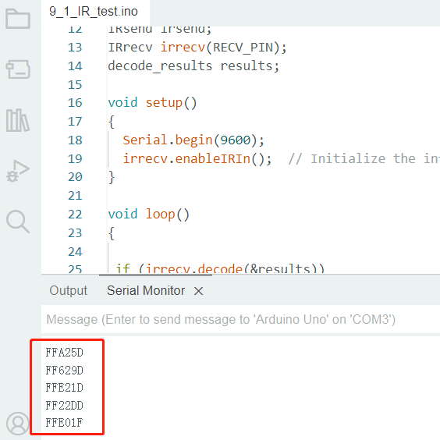

# 5. Code

**9\_1\_IR\_test.ino：**

#include <IRremote.h>

int RECV\_PIN = 3; //define input pin

IRsend irsend;

IRrecv irrecv(RECV\_PIN);

decode\_results results;

void setup()

{

  Serial.begin(9600);

  irrecv.enableIRIn();  // Initialize the infrared receiver

}

void loop()

{

 if (irrecv.decode(&results))

  {

    Serial.println(results.value, HEX);//print the value in HEX format

    delay(50);

    irrecv.resume(); // Receive the next value

    delay(10);

  }

}

# 6. Any questions and suggestions are welcome

Thank you for reading this document!

If you find any errors and omissions in the tutorial, or if you have any suggestions and questions, please feel free to contact us:

[cokoino@outlook.com](mailto:cokoino@outlook.com)

We will do our best to make changes and publish revisions as soon as possible.

If you want to learn more about smart cars, robots, learning kits and other technology products from us, please bookmark and pay attention to our website:

<http://cokoino.com/>

We will continue to launch interesting, cost-effective, innovative, user-friendly products.

LK COKOINO